Franz Kafka on AI
  - About the difference of being an algorithm – and being alive

“Go and look what you've gone done
Welcome oblivion”
– Nine Inch Nails: Less Than –

The law of robots is to obey. The law of men is to be free.
Programs thrive in following rules. A living spirit thrives in following its heart.
What constitutes a program are algorithms. What constitutes humans is free will.
To obey is inhuman.

The threat of AI lies not in what it is going to do with our lives.
We should better fear of what we have already become, to be building such machines.
For technology does not develop in vacuum, but reflects the culture of the society it was conceived in.
Building AI implies we think we function as machines do.

Century by century we seem to slowly lose all contact with our hearts.
Some neurobiologists already want to make us believe that we don’t have free will at all.
Evolutionary-psychologist can even explain why it is “rational” to believe we have it if we don’t.
We are on the verge of selling out our souls collectively.

But this is just the end phase of a long process.
We started to alienate from ourselves quite some time ago.
When and how has this inhuman metamorphosis really begun?
How deep goes the rabbit hole, we should climb out from?

The social construction of technology

Technology and humanity are inseparable. We play with fire. We use languages of abstract categories. Animals, unmistakably, don’t.
We evolve in a symbiosis with technology. We may perceive we are the product of it. Yet we are the ones producing technology. It is our child - with undeniable family resemblances.
We all know technology can have a great impact on our lives. The rise of the internet and smartphones prove this point as bright as daylight. But we easily forget how much our own lives induce technology. In the 19th century it was common belief even among scholars that the evolution of artifacts has an internal logic; that their development is a simple outgrowth of engineers tinkering in their workshops, and that there is a one-way causation from new inventions to changed social patterns. This view, called ‘technological determinism’, is nowadays mostly abandoned.
From the 1960s onwards researchers of the interdisciplinary STS (Science and Technology Studies) program provided illuminating arguments that external forces (culture, politics, economics etc.) always play important roles in research and innovations. By the end of the 20th century the theory of social constructivism (or Social Construction of Technology, aka SCOT) reached a conclusion opposite of determinism. As its name suggests, it argues that technological design is a function of social life. It is built on implicit assumptions and values about ourselves. A new technology is always a representation of who we believe we are, of what we perceive we do.

The cultural course of inventing photography
Among the many exciting examples within STS, one of my favorites is the invention of photography. As it is usually the case, it’s hard to tell when and who first used the technology: was it Jacques Charles in 1801, Thomas Wedgwood in 1802, Nicephore Niepce in 1826, William Henry Fox Talbot in 1835, or L.-J.-M. Daguerre in 1839? From a SCOT perspective this is not surprising: when the culture is ripe for it, a new medium may start to bloom in many places simultaneously. What is more striking, there is simply no internal reason why it hadn’t been invented a hundred years before.

Photography is the combination of two scientific features: that light passing through a small hole of a dark box projects an image on its back-wall (camera obscura), and that some silver composites turn dark when exposed to light. Now camera obscura (meaning: dark chamber) was known for Arabian scholars by 1038, and is mentioned by Roger bacon in the 13th century – from the middle of the 16th century Dutch painters already used to put convex glass lenses in the hole, to make their famously meticulous pictures. The chemical knowledge was also at hand for a while; the darkening of silver nitrate from sunlight was first recorded in 1614 by Angelo Salsa, and by 1725 Johanne Heinrich Schulze proved that the effect is due to light, not heat. “Considering that knowledge of the chemical as well as the optical principles of photography was fairly widespread following Schulze's experiment – which found its way not only into serious scientific treatises but also into popular books of amusing parlour tricks – the circumstance that photography was not invented earlier remains the greatest mystery in its history.”

On the other hand, if we look at it from a bigger perspective, and take into account the cultural history of painting, the mystery dissolves. As Peter Galassi argues vividly in his book, the invention of photography is an organic step in the evolution of pictorial tradition – not technically, but aesthetically. Before photos took on the duty of paintings to faithfully delineate their subject (enabling the forefather to enter abstract fields), western painters were experimenting with the linear perspective; ever since it was invented in the Renaissance. During the centuries this undertaking went through a fundamental change in the conventions of representation; from the so called synthetic to analytic imagery. In the 14th and 15th century a comprehensive style was applied, which worked from pieces to a whole: logically constructing all encompassing “plans”. From the 17th and 18th century a more fragmentary approach began to thrive, which worked from a whole to a single aspect: concentrating on the ‘vital spirit’ of the scene. Along this transformation of pictorial strategy (within the linear perspectivity), the self of the painter is put forward: the pictures start to encompass his personal presence on the scene, making their reception a more immediate experience.

We might see this evolution of representation as an organic follow up of even earlier developments. Before the application of linear perspective’s realism, painters wanted to depict what they perceived transcendentally. They applied a “Gods view” to show the truth: the Egyptian ‘vertical perspective’ is like a catalogue, listing every detail known; two hands, two eyes, one nose.. Byzantine paintings were more naturalistic, but didn’t have any depth, and size represented importance: what was more significant (religiously) was bigger. So the invention of the linear perspective is representing visually the revolution of humanism: the growing significance of the living people – in expense to heavenly transcendence. The development within the linear perspective seems following this track: the ever-gaining importance of our ego.

Circle of Piero della Francesca: An Ideal Townscape; around 1470, Panel, 24x79 in. Galleria Nazionale delle Marche, Urbino, Italy

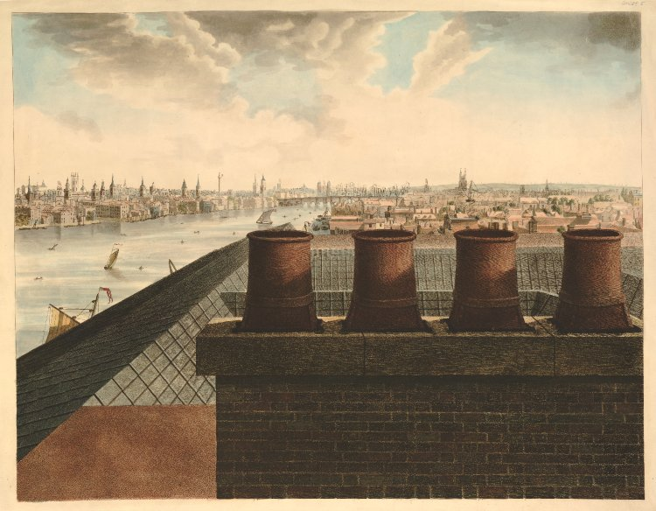
Robert Barker: A Panorama of London; 1791-92, Aquatint and etching, 1 of 6 sheets overall 17x132 in. Trustees of the British Museum, London

The synthetic style of early renaissance, though using a human’s vision, still composed an idealistic view of their subjects; presented symmetrically and in even light, often without people (see the picture ‘An ideal Townscape’). On the other hand the analytic painters chose a unique point in space, with a specific slice in time, often with lively situations. Getting their paintings ever more realistic, the view became more and more personal and seemingly occurrent (see ‘A Panorama of London’). And this aesthetical development is exactly what the technology of photography enables to further. As Galassi states: “The camera was a tool of perfect perspective, but the photographer was powerless to compose his picture. He could only, in the popular phrase, take it.” The photographs of the 18th century “represent the artistic capital that some early photographers made of this [analytic] strategy, which painters had long been inventing and which photographers could not avoid.”

So the most exciting perspective of SCOT theory is an intrinsic promise: that looking at our artifacts we can learn much about ourselves. The prevailing technologies are kind of a diagnosis of our social-psychological stand. We can ‘reverse engineer’ them to find out our tacit understanding of what we are: our social norms, cultural assumptions and beliefs about ourselves.
So what does the development of AI reveal about us?
How does the evolution of computers translate to a development inside our heads?

The rise of the machines
To understand what social forces yielded the construction of intelligent machines, we need to look at how (and why) we started to create machines in the first place. What did the industrial revolution represent culturally? We don’t need reverse engineering here – we know the answer.
The rise of the machines is the rise of rationality.
From a SCOT perspective the industrial revolution is the natural consequence of the “enlightenment”. Hand in hand with the scientific revolution, the 18th century is about the triumph of the intellect, abstract thought and disembodied mind (originating with Descartes of course) – and also the triumph of reductionism, materialism and the concept of progress. But to take the throne, the rationalists had to chase away the prior monarch: the soul. The spirit of the heart was exiled. And everything connected to it was stigmatized as obsolete: instincts, intuition, prejudice, superstitions and gut-feelings. The price of progress was alienation form ourselves; as Karl Marx’s well-known verdict of capitalism rightly declares.
The cruelty of rationality is spectacularly manifesting in the assembly line – the epitome of the industrial revolution. As Adam Smith demonstrates in his famous account of the Pin Factory (almost 100 years before The Capital is written), the rationalization of the work-flow equals to the division of labor. To produce more pieces of pin at a given day, the workers are assigned to do only one small task, repeating it the whole day (year). Their role on the job becomes bleak and inhuman. To work along the assembly line is notoriously monotone, robotic and despairing. The rigid aim of economic effectiveness acts inevitably against the emotional wellbeing of the work-force.
The rise of rationality is cutting our humanity down.
We let our minds strangle our hearts.
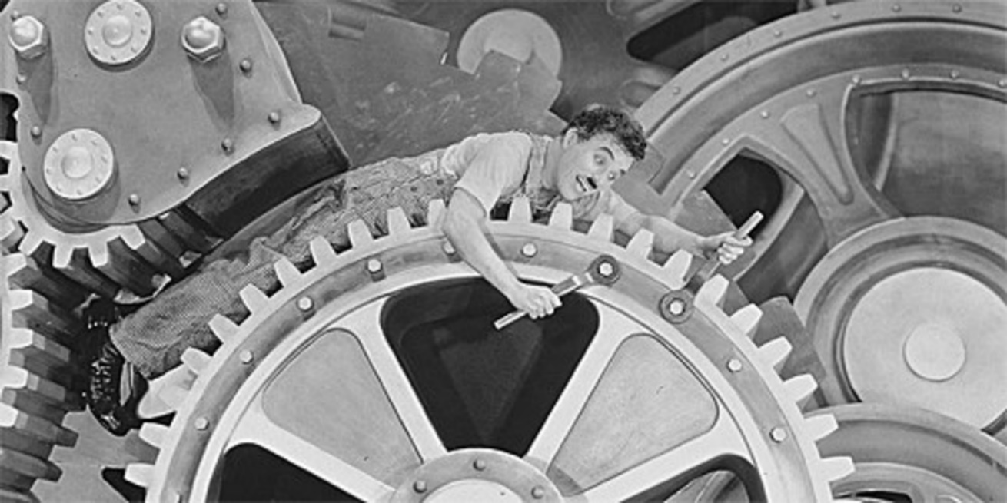
Charlie Chaplin - Modern Times (1936) “humanity crusading in the pursuit of happiness.”

Alienation has different aspects. The rise of the (steam) engine might be apprehended as the symptom of our alienation from our bodies. That’s why we had to invent sports: while we were harvesting with scythe and riding on horses, we were living through our own bodies every day. (That’s what true embodiment was about originally;)
The emergence of computers, then, can be seen as the alienation from our hearts. Culturally it roots in the philosophy of objectivism, realism and scientism – which converged in the program of the Vienna-circle. But these ideas soon popped out from the ivory tower of philosophy: the technology of the algorithm-based programs in the last 60 years developed side by side with the rise of cognitive-psychology. This disciplinary success sadly proves that as a society we are thinking of ourselves as being machines. Grounded on the vision of the very men who invented computers (most notably John von Neuman), the ‘mind-as-machine paradigm’ has by now penetrated our whole culture. Though from Heidegger through Wittgenstein to Polányi many bright minds have shown that this position is untenable, somehow it’s still impossible to eradicate this worldview from Academic circles. By now neurobiologists truly started to believe we don’t have free will at all. Evolutionary-psychologists deduce that free-will is only an illusion, and that “the primary evolutionary function of the self is to be the organ of impression management”.
This is shockingly wrong.
But what’s much worse, this oblivion about who we are is still gaining power every day. Now we have started to build AI, which promises that it will make all the decisions in our lives instead of us. Released from the burden of free will, now we can lay back at the easy-chair and enjoy the TV-shows uninterruptedly. After having alienated ourselves from our bodies and our hearts, we have started to alienate ourselves even from our minds. But shaking off the last drops of responsibility of our own lives, we will become nothing more than obeying robots.
This is by no means a necessary evolution. Nor is it a promising development.
It is bad news. Really.

The Metamorphosis
If we want to understand the deeply gruesome consequences of alienation, the Bohemian novelist Franz Kafka easily comes to mind. Though he died almost hundred years ago, his grim portrays of western societies haven’t faded the least. As one of the most sensitive writers of the last century, in his stories he vividly pictures the nuancedly detailed absurdity of modern life; how the insensitive and senseless structures of bureaucracy and capitalism strangle us emotionally. His verdict is clear: our own culture is hostile to life – we are building a deeply inhuman civilization. The very term ‘Kafkaesque’ entered the first words languages to help us describe this nightmare of bizarre oblivion.

In his novels (specially The Trial and The Castle) the protagonists are caught in the cogs of an unearthly bureaucratic machine. Getting more and more lost in the labyrinth of the inhuman and chaotic system, the first confident and joyful heroes are gradually losing all their hope and lifeforce. Though stuck in the poisonous web, they don’t stand any chance to face the depressingly powerful people pulling the strings. It is simply impossible to have a personal encounter with them: Kafka characteristically places these masters of life and death also physically above the laymen (in attics or on the hill), living parallel to the familiar world. His writings, though filled with exhilarating side-glances and deep irony, are grievously profound representations how the tangled rules of our modern hierarchies, laid down high above our heads, make us loose contact with ourselves – and with each other.

Though it’s a well-known fact, that the original English translators of his novels – the Scottish poet Edwin Muir and his wife Willa – were far from being good at their job, one of their main mistakes is the mistranslation of the title of “The Trial”. The German original ’Der Process’ means: the process. And it refers not only to the process Josef K.’s life is going through in the labyrinth of bureaucracy. It also depicts the whole procedure our culture undergoes by alienating ourselves. This is a peculiar ignorance, even the new critical translators seem to perpetrate.

Among his masterpieces, the short story The Metamorphosis (Die Verwandlung) is especially instructive for us to analyze. Since contrary to the novels, where we watch through the whole process of self-alienation from the beginning, here we start with the end-phase. In the very first sentence, the protagonist (Gregor Samsa) wakes up in his bed, finding himself to be changed into a ‘monstrous verminous bug’.
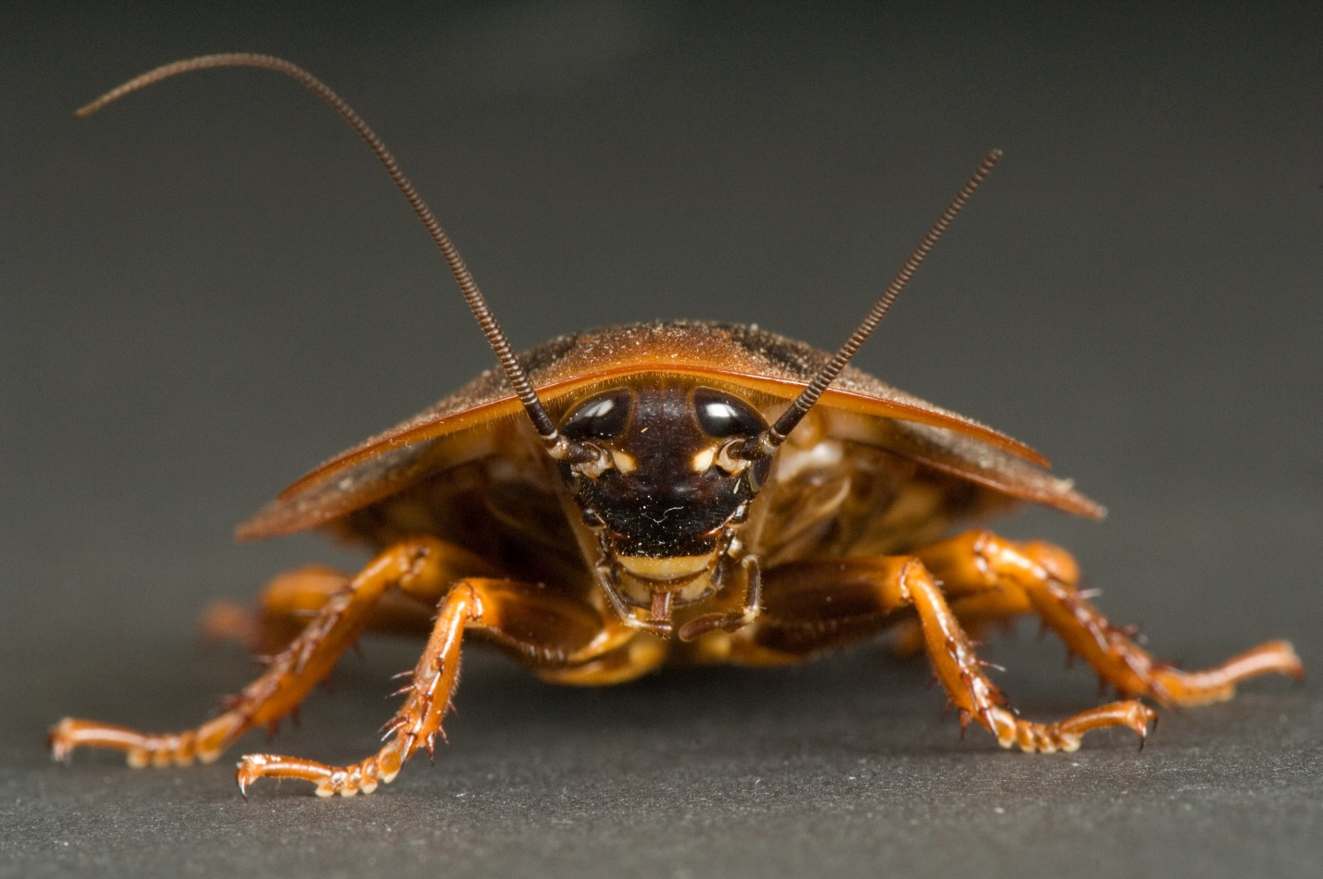
Photo by Joel Sartore/National Geographic/Getty Images

The story has, of course, been interpreted in various ways, including Freudian and feminist approaches, many of them accusing his family for Gregor’s ugly situation, and try forcefully to pity this maggot. Contrarily, in the sounder interpretations, which are in accord with the whole worldview of Kafka, the figure of the monster symbolizes the deprived existence of the protagonist. His body, transforming to this cockroach like bug, is only following suit to the metamorphosis his soul has gone through beforehand. Gregor’s life was absolutely inhuman. It is not worth living it. Totally joyless, his thoughts only revolve around how to obey others. Desperately trying to avoid any disappointment, his life is guided by fear. His existence is reduced to carrying out the will of his father and his boss – who despise him. But sacrificing himself for others doesn’t lead anywhere.

It’s important to note how grim Kafka views the act of obeying anything but our hearts – even if it is about helping others. Serving the needs of others without serving our own, is futile. And more than that: if we don’t fulfill our human duty to follow our hearts, we become not just useless, but a burden. Perhaps this is the most astonishing aspect about Kafka’s unclouded worldview, that he is brave enough to declare that Gregor’s help is actually draining energy from his family. Going fully against the tradition of Christian ethics, Kafka is unambiguous about the verdict on Gregor’s “life”. It’s only him who thinks his sufferings make the life of his family more pleasant. In reality his good will is poisoning the life of his beloved ones. Only when becoming unable to earn money, and thereby forcing his parents and sister to work themselves, can they regain their lifeforces. At the end of the story, when our “hero” finally dies, we see the whole family finally happy and shining. So Gregor, becoming nothing more but a working robot, is not only harming himself – he becomes a dangerous parasite. Even before his physical metamorphosis, as he alienates from his own heart (the Czech word sam means ‘being alone’) he becomes a zombie. By losing contact with our own soul, we necessarily become evil.

The German phrase Kafka uses to refer to the maggot Gregor transforms to (“ungeheueres Ungezifer”) makes this univocal. Literally this translates to ‘a terrible pest’, but etymologically it also bears the meaning of not being a creature of God. (‘Un-’ is a privative suffix, ‘-geheuer’ means: to be peaceful, kind, calm, trustful. ‘-Gezifer’ means: to be offered to God. Thus he is a ‘dangerous beast’.) So the existence of the protagonist is not only void of sense – he is evil.

We are taught in scientific biology class that the definition of life is to feed on some resources and to be able to reproduce. But this definition only suffices to describe the characteristics of a virus and other parasites. A living soul is more than that: it has a heart, who’s call it has to attend. Obeying something other than our hearts makes us programs. Be it fear or the delusion of money – it leads to selling our souls. Our languages still remember this difference between being only an algorithm or being truly alive: pests and vermin are not godly creatures. They are not to be spared. Who has ever felt her heart to feel affection to a cockroach? Who has ever wanted to pet a mosquito? Nobody. They are soulless – evil by design.

The rationality of biology can’t comprehend this distinction. Science wants to make us forget what our languages are keenly teaching us. Our heart knows that. Yet we want to force it into oblivion.

We strongly need to remind ourselves to this difference.

Adolf Eichman vs. Stanislav Petrov
The 20th century gave us many examples that following rules blindly is not simply inhuman – it’s evil. It doesn’t only ruin our own lives, but everybody else’s around us.

Word war II supplies many evidences in itself – the most illustrious is probably the case of Adolf Eichmann, Nazi SS-Obersturmbannführer. Being the chief organizer for the “effective” transportation and elimination of millions of Jews, he was believed by many to be the devil himself. When he was finally captured in 1960, his trial in Jerusalem was expected by many to bring justice to humankind, by convicting the vicious guy. But instead of finally confronting the devil with its deeds, he turned out to be a dull bureaucrat, “only” following orders. He maintained throughout the interrogations that he was “forced to serve as a mere instrument” in the hands of his superiors. He was convinced – as his convicted fellows at the Nürnberg trials – that since he was not a responsible leader, he is not guilty at all. Hanna Arendt’s insightful report on the trial in Jerusalem, the Banality of Evil summarizes the important conclusion in its title: to be evil doesn’t depend on being vicious. Being a good soldier and fulfilling orders without taking the responsibility for them, is what true wickedness is about.

On the other hand, following our heart responsibly can makes us become “the hand of God” in a way.
Like in the case of Stanislav Yevgrafovich Petrov, lieutenant colonel of the Soviet Air Defence Forces, who is said to have “single-handedly saved the word from nuclear holocaust”. Serving to monitor the nuclear early-warning system in 1983, midst of the cold war, one day the computer reported a missile strike from the US. Though according to military protocol he should have transmitted this along the chain of command without hesitation, he judged the computer to be wrong, and reported his superiors it was a false alarm. Though he had reasons to believe the computer was mistaken – as later turned out the alarm was due to a rare alignment of sunlight on high-altitude clouds – he couldn’t be sure. But he was well aware that a Soviet missile response could have led to a large-scale nuclear war with NATO allies, and he didn’t trust his superiors they could comprehend these information. Being the only one with civil training among pure military professionals, he was able to override the strict orders. Since soviet top leadership at the time was on hair-trigger alert, having only minutes to decide with such an information they probably would have made a decision to retaliate. By trusting neither the computer, nor his superiors, but taking full responsibility of his actions, Petrov has probably saved millions of lives.

Point of no turning back?
Franz Kafka wrote The Metamorphosis more than a 100 years ago. We didn’t seem to have tried at all to revise our course since then. We let proudly the rationality of our minds alienate us from our bodies and our hearts; now we started to get alienated from our minds. We don’t seem to worry at all – on the contrary, we eagerly pray to our new god: that of Dataism.
Technology is not necessarily bad of course – I am very happy to be able writing this on a word-processor. But I’m not gonna follow all his proofing suggestions.
Rationality is a very useful tool – as long as we can keep it on a leash. But we are way beyond that.

Even if we wanted to change route; overriding the momentum of hundreds of years of cultural amok is not an easy task. Nor alone, nor together. Our societies promote alienation at least since Descartes – though according to Kafka, we might need to go back till the birth of Christian ethics. But even to undo the damage done on our souls, only since the enlightenment: we should know what we are fighting for. Sadly enough, we barely remember anything of what we have lost.
We have been alienated from our bodies beyond hope. We don’t even try to listen inwardly to know how we feel – we use machines to decide if we are healthy or not. We measure our temperature, heart-rate, blood-composition, we apply CT, MR and ultrasound devices. We even use a pedometer to decide if we got tired or not. Western medicine imperiously takes away all responsibility from the sick. We truly believe that a stranger can know more about us then we do – and follow the doctors advice as they were gods. It doesn’t even matter if we really feel good: if some computer calculates hazards, we are obliged to follow precautional steps. Nobody thinks anymore this is insane. Even the few scholars aware of the dangers of AI believe that western medicine combined with Big Data is a promising side of technological development. It is not. Unassisted childbirth is already illegal in many “civilized” countries. If we keep this track, soon it will be against the law not going in hospital if we get a headache.
We are alienated also from our hearts awfully. As a culture we deny that free will could have a good side: without rules to be followed “there would be mad chaos” – we are told on every corner. Parents believe loving their children means to make decisions above their heads constantly. Who is strong enough to let her four-year-old decide when to go to sleep? Who believes his kid is smart enough to decide when he is hungry, when she feels cold? Almost nobody – yet these would be only the first steps to self-knowledge. Our schools are but temples of obedience. Children are not grading their teachers. They are not allowed to decide what subject they are interested in. Usually we don’t even let them chose their carriers – because we want them to be “successful”. We want them to get a job in a big corporation, when they can obey some more. But if we don’t believe in the free will of our children, they’ll never grow up.
Of course, we didn’t grow up ourselves. We don’t believe in personal responsibility anymore. We live in a culture of infantility.
The only place left by now to freely decide, is how we want to spend our money – but here come the robots to take this away too. They already started to decide what to read, what to watch, what to listen to – even where and when to buy what we want. And nobody seems to be offended to get a discount at the “right moment”.
Yet the more efficient our economies become, the less happy we can be. To find peace and true happiness we must follow our hearts. Following our minds leads nowhere. Of course it can make us rich. It can help to become famous or successful. But it’s incapable to show the way to a deep satisfaction with ourselves.
Maybe our only hope is to keep running on this track a little more. Maybe AI will take away all our jobs soon enough, and we will have so many free time, we can’t spend it on anything else but us. Maybe the world of robots will help people find a way to reconnect with themselves. Maybe then we’ll relearn how to listen to our hearts.
Of course, it’s far from obvious that unemployed people now days would find their hearts more easily. They don’t seem to be more responsible or happy than the average. But what else can we hope for? We are caught eye-ball deep in this process of becoming ungodly pests.
It seems very hard to save us from ourselves.

János Liska
2019

References:
Alder, Ken: Making Things the Same - Representation, Tolerance and the End of the Ancien Régime in France; Social Studies of Science, Vol. 28, No. 4 (Aug., 1998), pp. 499-545
Alt, Peter-André : Franz Kafka: Der Ewige Sohn; C.H. Beck, 2005
Arendt, Hannah: Eichmann in Jerusalem - A Report on the Banality of Evil; Viking Press, 1963
Barkow, Jerome H.: Folk Psychology, Free Will and Evolution; Journal of Ideas, 1991, 2: 63-66
Bear, Adam: What Neuroscience Says about Free Will; Scientific American, April 28, 2016; https://blogs.scientificamerican.com/mind-guest-blog/what-neuroscience-says-about-free-will/?redirect=1

Bloor, David: Knowledge and Social Imagery, University of Chicago Press Ltd, London, 1976
Burke, John G.: Bursting Boilers and the Federal Power; Technology and Culture, Vol. 7, No. 1. 1966; 1-23
Coetzee, J.M.: Kafka: Translators on Trial; The New York Review of Books, May 14 1998; https://www.nybooks.com/articles/1998/05/14/kafka-translators-on-trial/
Feyerabend, Paul: Against method; New Left Books, London, 1975
Galassi, Peter: Before photography: painting and the invention of photography; The Museum of Modern Art: Distributed by New York Graphic Society, 1981
Gernsheim, Helmut & Alison: The History of Photography From the Earliest Use of the Camera Obscura in the Eleventh Century up to 1914; Thames & Hudson; London, 1969, p13
https://en.wikipedia.org/wiki/Stanislav_Petrov
Lakoff, Georg: Women, Fire, and Dangerous Things; The University of Chicago Press, Ltd, London, 1990
Kafka, Franz: Der Prozess; Fischer Taschenbuch Verlag, Frankfurt am Main, 2011
Kafka, Franz: The Metamorphosis; Classix Press, 2009
Kafka, Franz: A kastély, Magvető, Budapest, 2018
Kuhn, Thomas: The Structure of Scientific Revolutions; University of Chicago Press, 1962
Sudau, Ralf: Interpretationshilfen Kafka: Erzählungen; Klett Ernst/Schulbuch, 2007
Wright, Robert: The Moral Animal, Vintage Books, New York, 1994

See for example Thomas Kuhn, Paul Feyerabend, David Bloor..
See for example Ken Alder: Making Things the Same - Representation, Tolerance and the End of the Ancien Régime in France; Social Studies of Science, Vol. 28, No. 4 (Aug., 1998), pp. 499-545; and John G. Burke: Bursting Boilers and the Federal Power; Technology and Culture, Vol. 7, No. 1. 1966; 1-23
Helmut Gernsheim & Alison Gernsheim: The History of Photography From the Earliest Use of the Camera Obscura in the Eleventh Century up to 1914; Thames & Hudson; London, 1969, p13
Peter Galassi: Before photography: painting and the invention of photography; The Museum of Modern Art: Distributed by New York Graphic Society; 1981 (https://www.moma.org/documents/moma_catalogue_2267_300296442.pdf)
Of course, linear perspective didn’t fall out of the sky either. The transition from the Byzantine inverse perspective and axonomic projection is closely tied to the humanist movement of the Middle Ages, according to which the point of view of an omnipresent God is replaced with a more naturalistic, empirical viewpoint of a person.
For a detailed comprehension of different representational forms and worldviews, see Paul Feyerabend: Against method; New Left Books, London, 1975. See especially chapter XVII in the 3rd appendix.
Peter Galassi (1981), p- 17
Ibid. p. 18
As David Bloor summarizes Edmund Burke’s zeal about prejudice in his ‘Reflections on the Revolution in France’ (1790): “Prejudice has the inestimable advantage over the calculating reason of the individual that it is attuned to action and that it creates continuity.” David Bloor: Knowledge and Social Imagery, University of Chicago Press Ltd, London, 1976 – especially in chapter 4, p. 66.
As Georg Lakoff summarizes, this position states more elaborately, that 1: we are but abstract symbol manipulators, and 2: that a neutral conceptual framework could represent everything. Georg Lakoff: Women, Fire, and Dangerous Things; The University of Chicago Press, Ltd, London, 1990
Adam Bear: What Neuroscience Says about Free Will; Scientific American, April 28, 2016; https://blogs.scientificamerican.com/mind-guest-blog/what-neuroscience-says-about-free-will/?redirect=1
Jerome H. Barkow: Folk Psychology, Free Will and Evolution; Journal of Ideas, 1991, 2:63-66 (emphasis by me); Robert Wright even says "the realm of consciousness itself is in large part such a press agent” in The Moral Animal, Vintage Books, New York, 1994, chapter 13 (emphasis by me).
J.M. Coetzee: Kafka: Translators on Trial; The New York Review of Books, may 14 1998, https://www.nybooks.com/articles/1998/05/14/kafka-translators-on-trial/
Following e.g. Peter-André Alt and Ralf Sudau
Evidentially, although we see the story through this bug’s eyes, he is actually the villain. The only true role model in the novel is the Charwoman, who’s acts are driven by joy. Of course she wants to kill Gregor right on sight!
According to Wikipedia “the influences on his decision included that he was informed a U.S. strike would be all-out, so five missiles seemed an illogical start; that the launch detection system was new and, in his view, not yet wholly trustworthy; that the message passed through 30 layers of verification too quickly; and that ground radar failed to pick up corroborative evidence, even after minutes of delay.” https://en.wikipedia.org/wiki/Stanislav_Petrov

